CODES GENARATED BY GITHUB COPOILET:-

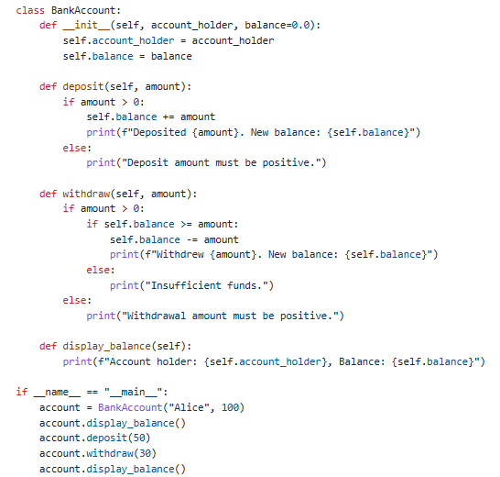TASK1:-

Code:-

Output:-

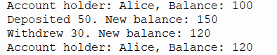

TASK 2:-

CODE:-

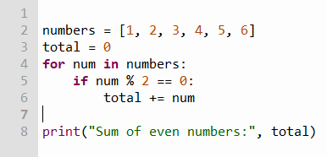

Output:-

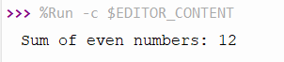

TASK 3:-

CODE:-

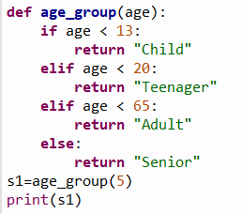

OUTPUT:-



TASK 4:-

CODE:-

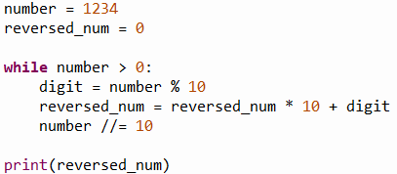

OUTPUT:-



TASK 5:-

Code:-

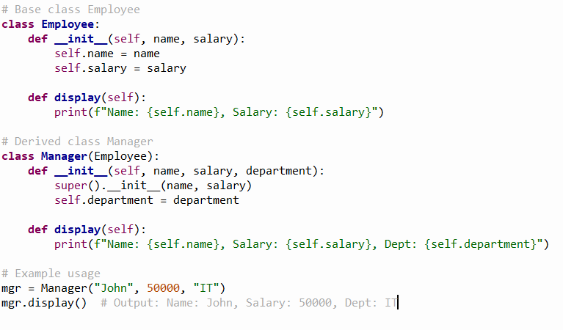

OUTPUT:-

